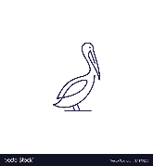
Corpus MCR Community Grant
Proposal Form
Please fill in the form below and send to mcr_treasurer@corpus.cam.ac.uk
The process for community grant approval depends on the amount requested. For further details, see Community Grants.
Please speak to the MCR Treasurer if you have any questions about community grants.
If you’d like to discuss this proposal with another member of the committee, find their email address here: Committee.
Proposer:
Seconder: (optional*)
[*it is helpful to know that you’ve discussed the proposal and that other people think it’s a good idea]
Overview:
Benefit to Community:
Details: (including price estimates, with links to items for purchase, would be very helpful)
Total Cost Estimate:

